**DAILY ONLINE ACTIVITIES SUMMARY**

|  |  |  |  |  |  |  |  |  |
| --- | --- | --- | --- | --- | --- | --- | --- | --- |
| **Date:** | **19/06/2020** | | | | | **Name:** | **V ANJANA PAI** | |
| **Sem & Sec** | **IV sem & B section** | | | | | **USN:** | **4AL18CS094** | |
| **Online Test Summary** | | | | | | | | |
| **Subject** | | **MICROCONTROLLER AND EMBEDDED SYSTEMS** | | | | | | |
| **Max. Marks** | | **20** | | **Score** | | | **13** | |
| **Certification Course Summary** | | | | | | | | |
| **Course** | **Introduction to Information Security** | | | | | | | |
| **Certificate Provider** | | | **Great learning academy** | | **Duration** | | | **5.5 hours** |
| **Coding Challenges** | | | | | | | | |
| **Problem Statement1:** Write a C Program to rotate a Matrix by 90 Degree in Clockwise or Anticlockwise Direction.  **Problem Statement2:** Write a C Program to Count total set bits in all numbers from 1 to n. | | | | | | | | |
| **Status: Executed** | | | | | | | | |
| **Uploaded the report in GitHub** | | | | | **YES** | | | |
| **If yes Repository name** | | | | | **lockdown-coding** | | | |
| **Uploaded the report in slack** | | | | | **YES** | | | |

Online Test Summary:18CS44 test was scheduled from 3:00pm t0 3:30pm. The portion for the IA was 4th module there were 20 questions and the time assigned was 30 minutes the questions were mcq type.

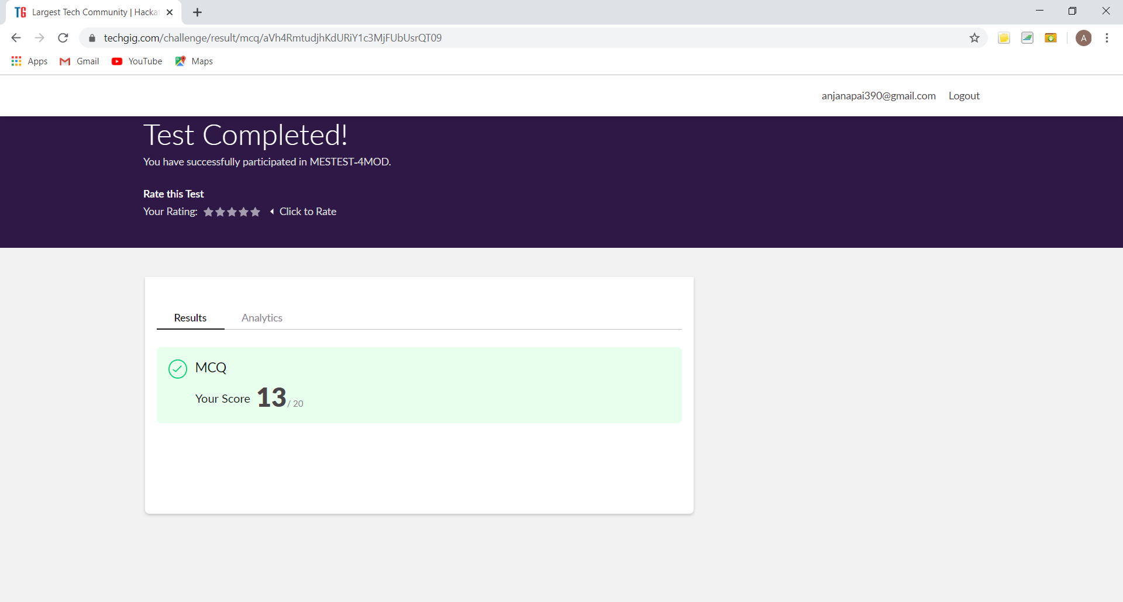

This is the snap shot of the test completed and marks obtained.

Online Certification Course Summary: Today I learnt about the Introduction to Software Security Lesson 2.

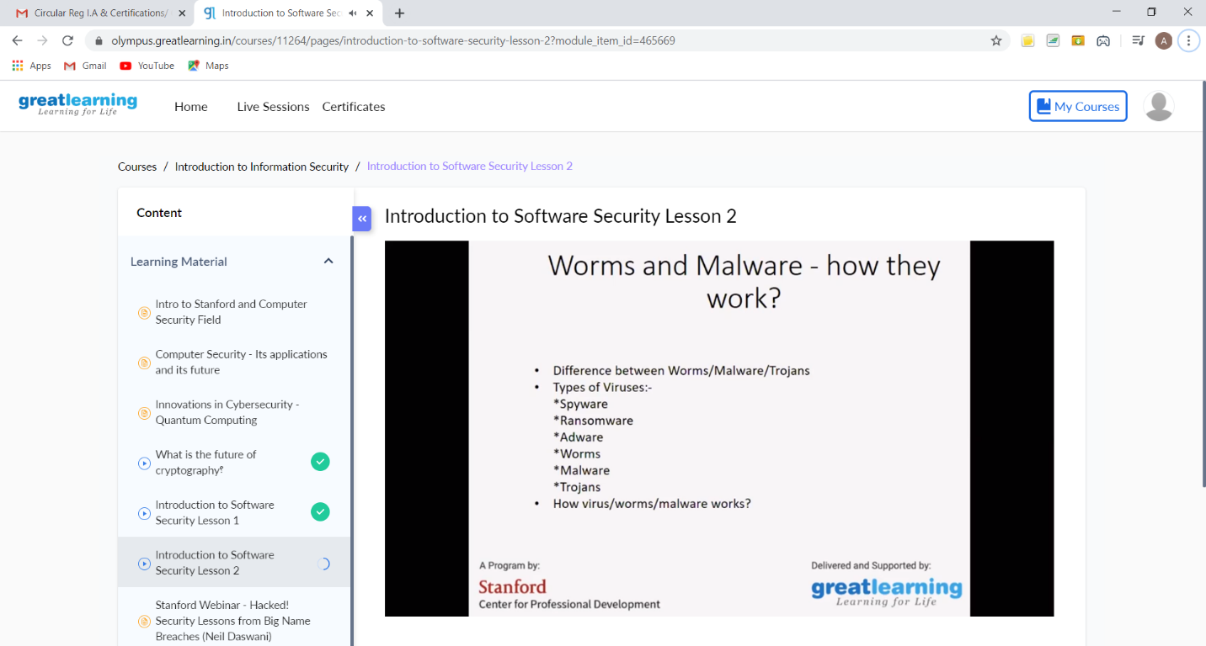

This is the Snap shot of today’s session.

Online Coding Summary: **Today I had received one program from prof. Shilpa CSE Dept. and from Prof. Venkatesh CSE Dept. The program is mentioned above in the coding challenges(pg.01). I have also uploaded it to my GitHub repository.**

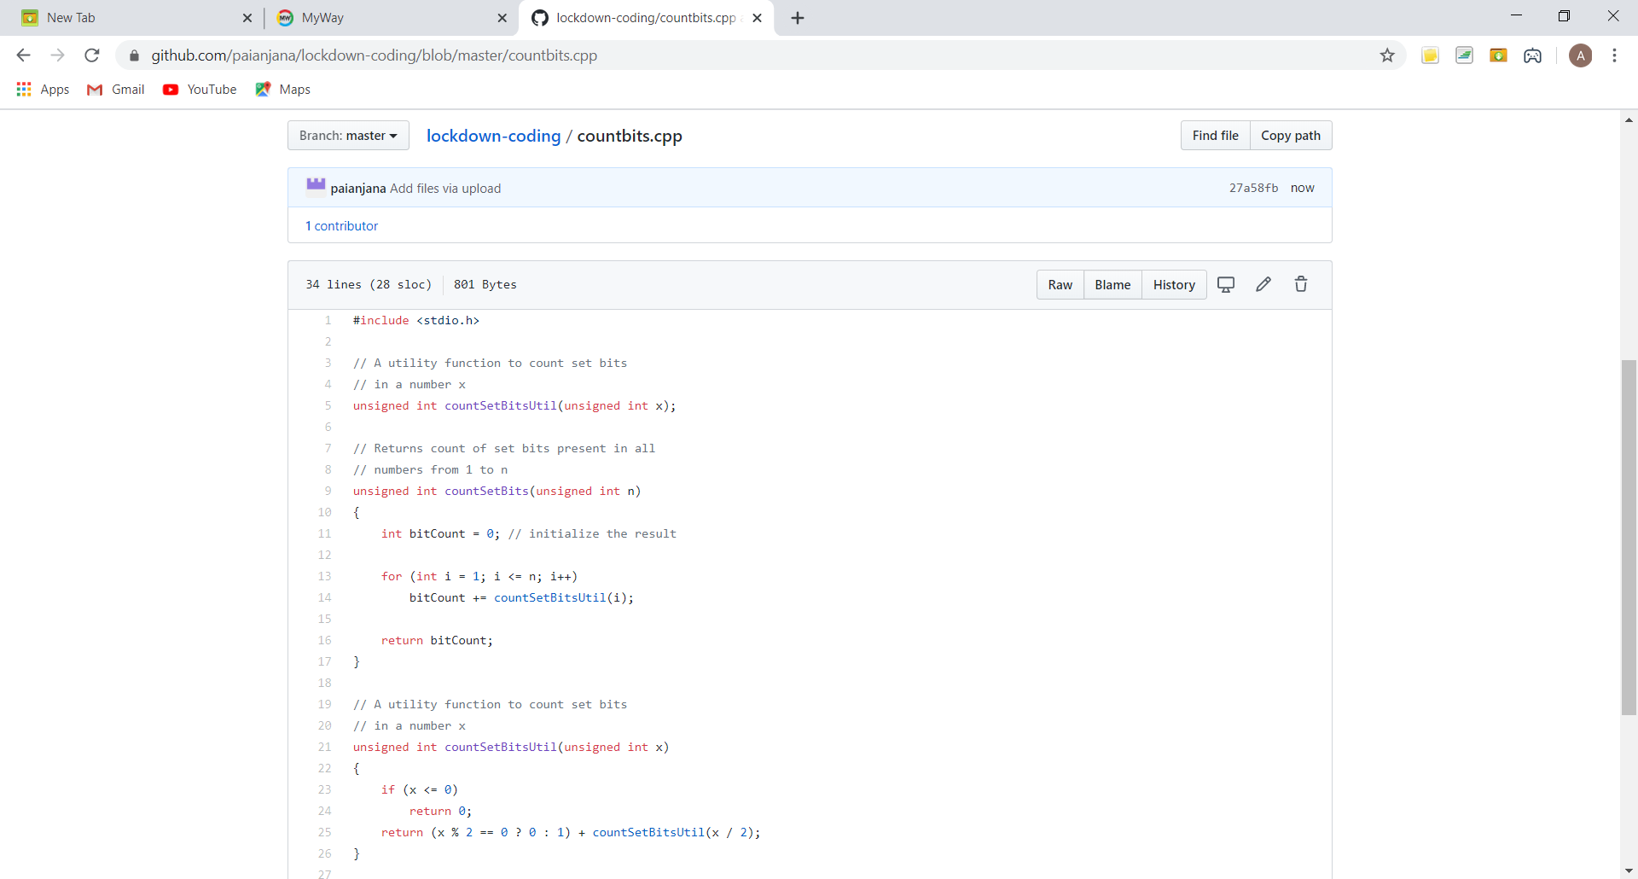

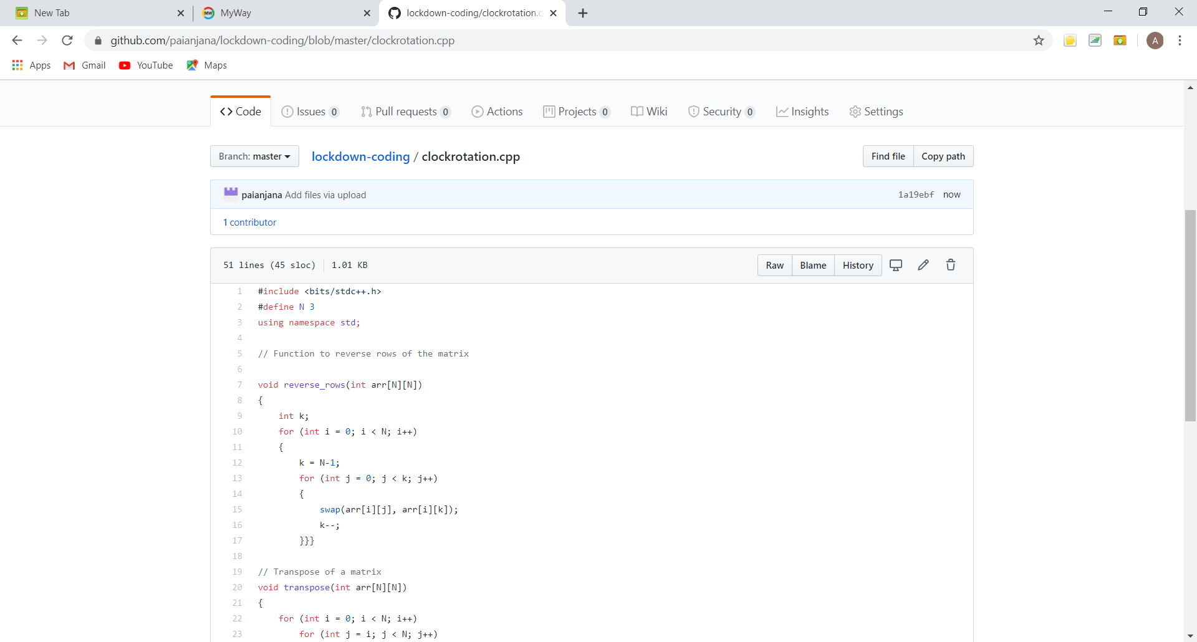

**This is the snap shot of my GitHub repository** where I have uploaded the code. File name is countbits.cpp and clockrotation.cpp